DATABASE BACKUP

Database-backup.php:

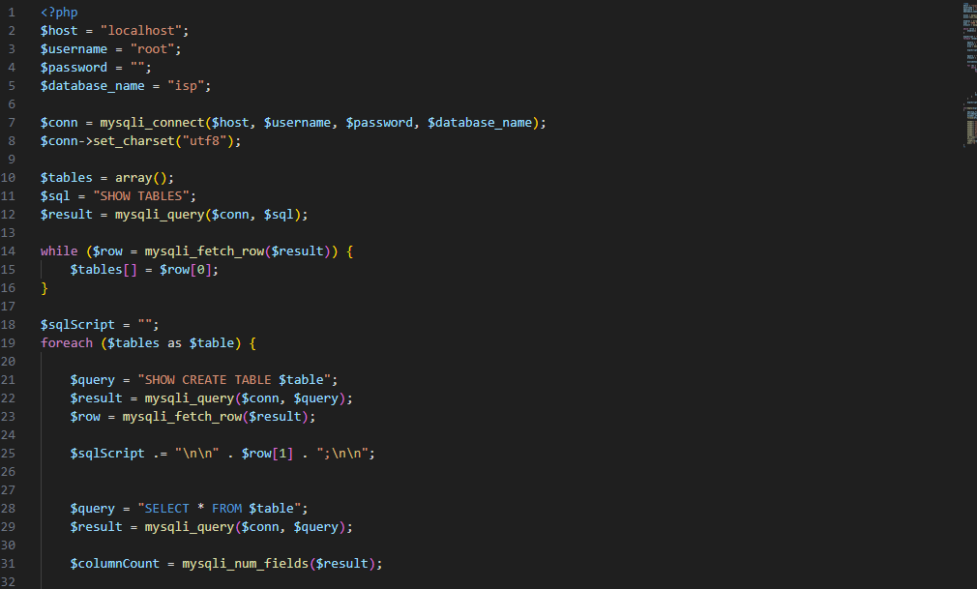

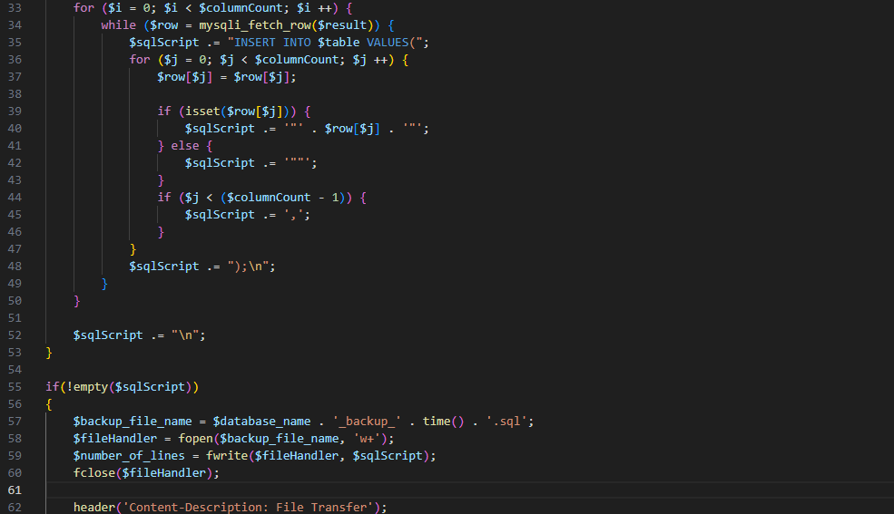

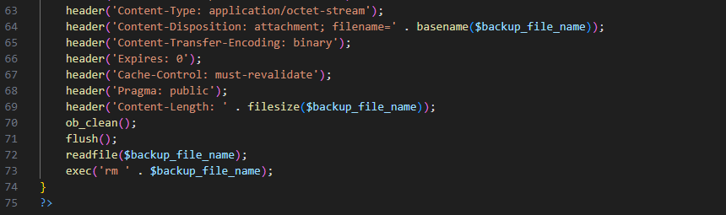

Output:

DOWNLOADED BACKUP:



